List of changes.
New changes highlighted in Yellow letter

- Kinetics adc measuring time is 10Sec. In KineticAvgTimeX taking average of 0 to 9 = 4.5 but it should take the average of 1 to 10 = 5.5

I changed the formula like shown below.

for(int nI = 0 ; nI < MaxNumOfMeasurement ; nI++)//Loop to calculate average time
{
KineticAvgTimeX += (nI+1) ;//summing with time values.
}
KineticAvgTimeX /= MaxNumOfMeasurement;//divideing to calculate average time.

Same as below x starts from 0 to 9 but it should start from 1 to 10. So I changed the formula like shown below.

for(int nI = 0 ; nI < MaxNumOfMeasurement ; nI++)//Loop {

/*Calculation of sum of all (x - x') * (y - y')*/
SumOfxXyY += (((nI+1) - KineticAvgTimeX) * (stcTestData.PrimaryAbsBuffer[nI] - KineticAvgAbsY));//xX[nI] * yY[nI];

/*Calculation of sum of all (x - x') Square*/
SumOfxX2 += (((nI+1) - KineticAvgTimeX) * (nI - KineticAvgTimeX));//xX[nI] * xX[nI];
}

- double bSlope = SumOfxXyY - SumOfxX2; // slope abs value per second. Using this value, we need to calculate the final result
Need to change the formula to double bSlope = SumOfxXyY / SumOfxX2;

- double TimeMins = (bSlope / 60) ;//Abs/sec changed to min

double TimeMins = (bSlope * 60) ;//Abs/min converting to 60sec(1min)

- Aspiration process changed like this.
case enTestStatus_Aspiration:
DebugOvrUsbCdc("Aspiration , Voleume" , IntToCharConverter(stcTestparams[stcTestData.TestId].AspVoleume));
AspiratePump(stcTestparams[stcTestData.TestId].AspVoleume);
stcTestData.AdcDataFetchCount = 0;
stcTestData.CurrentTestStatus = enTestStatus_Incubation;

BeepBuzzer(); //added
HAL_Delay(2000); //added
AspiratePump(DEFAULT_AIRGAP_VOLEUME);//Aspiration of Air gap //added

break;

- Need to add auto empty of 500uL in waiting for next step
case enTestStatus_WaitingForNextStep:

instead of airgap aspiration, we need to give auto empty of sample after reading the adc.

AspiratePump(stcTestparams[stcTestData.TestId].AspVoleume);
//auto empty.

Remaing process

- After the 1st sample test OD result, the program is hanging (looping in tasks.c) not going into wash program.

Line- 3403 portALLOCATE_SECURE_CONTEXT( configMINIMAL_SECURE_STACK_SIZE );

Line-3432 if( listCURRENT_LIST_LENGTH( &( pxReadyTasksLists[ tskIDLE_PRIORITY ] ) ) > ( UBaseType_t ) 1 )
{
taskYIELD();
}
else
{
mtCOVERAGE_TEST_MARKER();
}
}

- Buzzer not working properly.

- JSON command Sample OD negative values also showing in positive only.

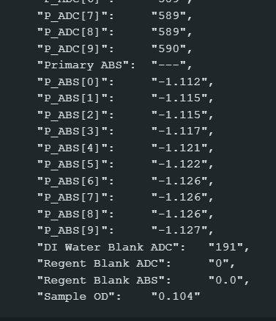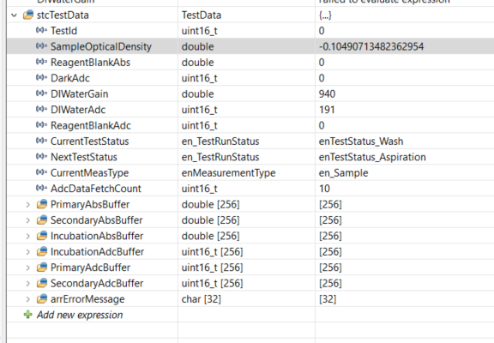

Here the Sample OD is = -0.004317 but it is sending only 0.4
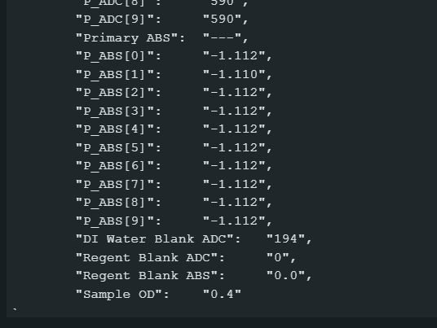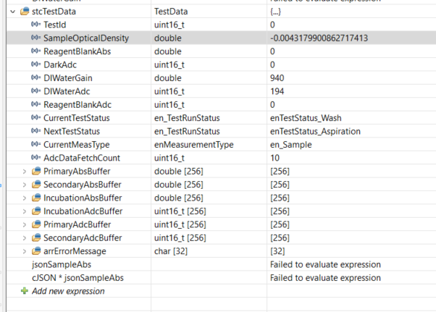

Here the Sample OD is = -0.0033167 but it is sending only 0.331

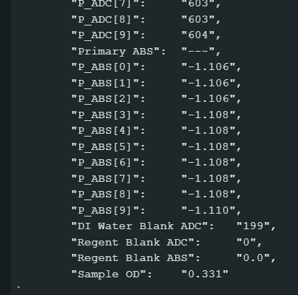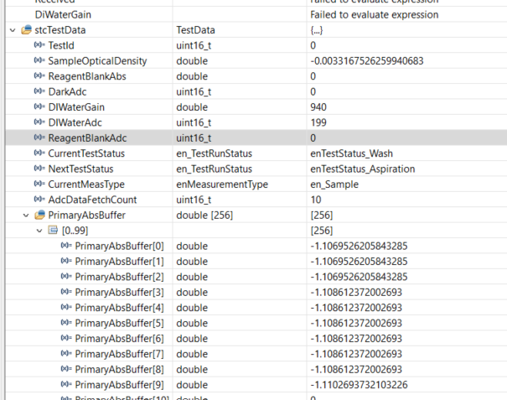

- Biochromatic test only in End point test method.

Formula needs to change like this: -
OD = PrimaryAvgAbs - SecondaryAvgAbs;//Calculation of final OD

- 2 Point and turbidity test method need to add.

